Iowa Department of Health and Human Services

We can help you get your life back by helping you quit vaping and other tobacco products. It’s free, confidential and only takes a few minutes to join. Start here: ia.mylifemyquit.org

Iowa Department of Health and Human Services




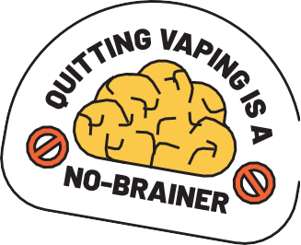
Think of My Life, My Quit as your understanding friend who just wants to help you be your best self. Our coaches are always standing by to help you quit vaping. Start here: ia.mylifemyquit.org

Iowa Department of Health and Human Services

Why are you ready to quit vaping? Whatever the reason, we’re here to help with free, confidential support. Text “Start My Quit” to 36072 or sign up here: ia.mylifemyquit.org

Iowa Department of Health and Human Services

When you quit vaping, chewing, smoking or nicotine pouches, you help your body be healthier. Isn’t that a great reason to start quitting ASAP? Learn more: ia.mylifemyquit.org


Quit Tobacco and Join the
TEENS
Who Have Taken Their Lives Back

Free. Conﬁdential. Totally
non-judgmental.
AKA: Everything You Want to QUIT VAPING


Protect Your
Brain and Lungs
Save Lots of Money
Feel Less
Stressed

QUIT VAPING TO:
To 36072 To
Quit Tobacco
Your Brain, Lungs
AND Other Organs
Will LOVE You For It

TEXT
“Start My Quit”

Iowa Department of Health and Human Services



Vaping costs really add up, with teens spending as much as $500 a month. How many concert tickets, pairs of shoes, video games and <insert whatever you love here> could that money buy. Get free, confidential help quitting: ia.mylifemyquit.org

Iowa Department of Health and Human Services

By quitting vaping and other tobacco products, you can improve your health, self-esteem and more. My Life, My Quit is here with free, confidential support: ia.mylifemyquit.org

Iowa Department of Health and Human Services

Quitting vaping is good for your health — and the environment. My Life, My Quit offers free, confidential support to help you quit. Text “Start My Quit” to 36072 or start chatting now: ia.mylifemyquit.org

Iowa Department of Health and Human Services

My Life, My Quit coaches don’t just give you good vibes when you want to quit vaping. They give you real ways to make quitting easier! Learn more and sign up for free: ia.mylifemyquit.org

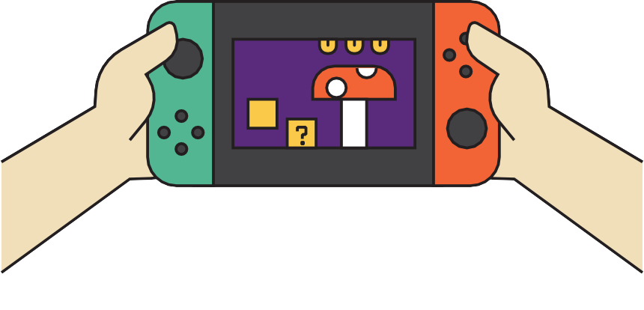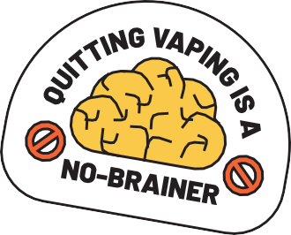

YOU
A: A 3-month supply of vapes
B: A new gaming system
WOULD
RATHER

YOU
A: Be Winded Going Up the Stairs Because of Vaping
B: Be your sport’s MVP
RATHER
WOULD
GROSS FACT ALERT:
850 Million
VAPES
End Up in the Landﬁll Each Year

Vibes Only
TEXT
“Start My Quit”
To 36072 To
Quit Vaping

Iowa Department of Health and Human Services

With My Life, My Quit, you get free, confidential support from people who get you and what you’re going through. It only takes a few minutes to start your quitting journey: ia.mylifemyquit.org

Iowa Department of Health and Human Services

Whatever your reason, My Life, My Quit will be there for you every step of the way with free, confidential and non-judgmental support. Text “Start My Quit” to 36072 or chat with a quit coach here: ia.mylifemyquit.org

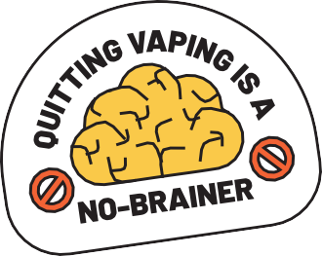

VAPES. CHEW. CIGARETTES. NICOTINE POUCHES.
We Can Help You Quit It All

I’m Ready to Quit
VAPING Because:

